## 1. A short description of your activities for installation of the above-mentioned tools (what problems did you face)

Answer：

### Installation of Java EE SDK

step 1: go to <http://java.sun.com/javaee/downloads/index.jsp>

step 2: click “Download with JDK”

step 3: select Windows as Platform, English as Language, confirm the license and continue

step 4: click java_ee_sdk-5_04-windows.exe and run

step5: follow the instruction to install Java EE SDK

### 1.2 Installation of Eclipse

step 1: go to <http://www.eclipse.org>

step 2: click “Download Eclipse”

step 3: click “[**Eclipse IDE for Java Developers**](http://www.eclipse.org/downloads/download.php?file=/technology/epp/downloads/release/20071103/eclipse-java-europa-fall2-win32.zip)”

step 4: download eclipse from one of the server

step5: unzip the package

step6: run %ECLIPSE_HOME%\eclipse.exe

### 1.3 Installation of XML Spy

step 1: search XML SPY in Google

step 2: go to XML SPY download page: <http://www.altova.com/simpledownload2.html?gclid=CN-66rOUkpECFQFZQgodP0RsOw>

step 3: download XML SPY

step 4: install XML SPY

step 5: enter name, company and email at starting to get a 30 days trail key

step 6: check email and copy trail key to XML SPY active form.

## 2. Edited XML Schema for your resume (with comments on what was modified compare to initial schema)

Answer:

We edit the XML schema and name it ***MyAnnotatedSchema.xsd***

Changes are:

1. Delete three nodes, which are *OnBoardAvailability*, *Objectives*, *ProfessionalAssociations*
2. Add two nodes, which are *SkillSet*

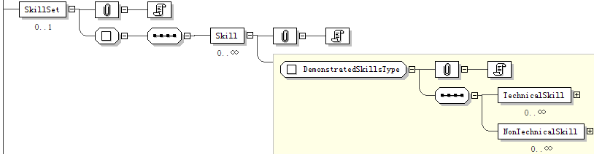

and *Hobbies*

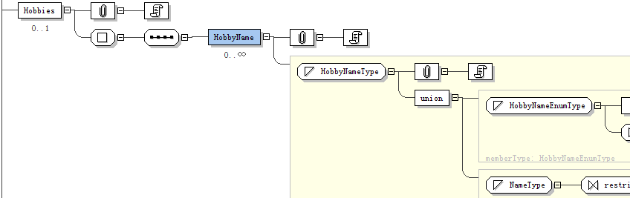

1. Add a simpleType *HobbyNameType*

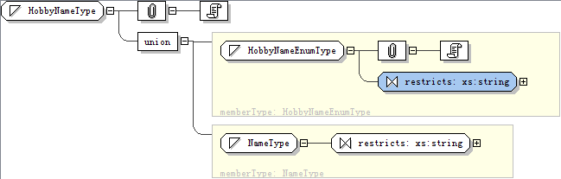

which is union of simpleType *HobbyNameEnumType*

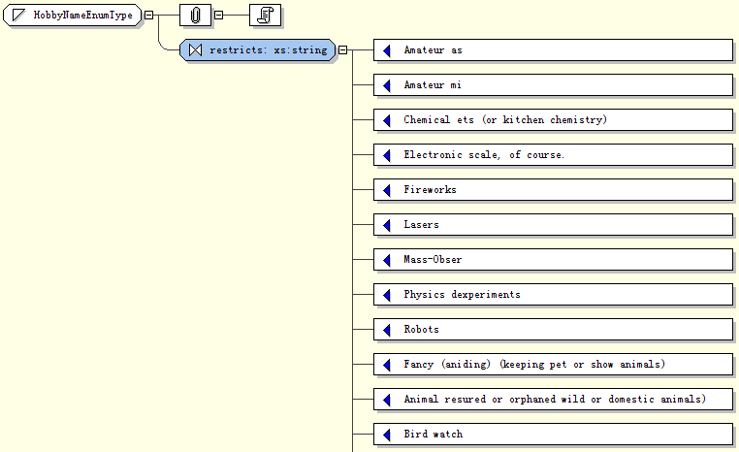

and simpleType *NameType*

1. *Modify the* simpleType *PostalCodeType, change the pattern of restriction from [1-9][0-9]{5}* to *[1-9][0-9]{4}*

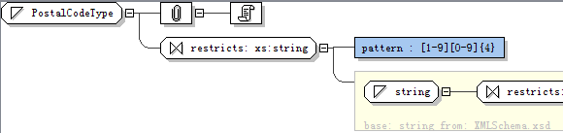

## The tree of Java classes generated after compiling your XML Schema

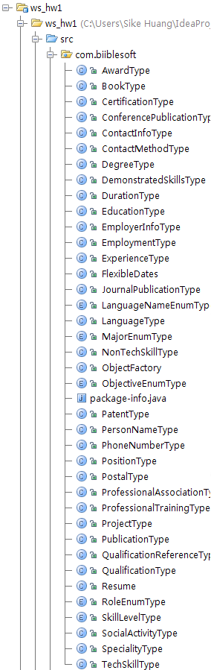

## Source code of Java programs that creates Java content tree for your resume and marshals it to the Resume.xml file.

See ***MyResume.java*** in the project.

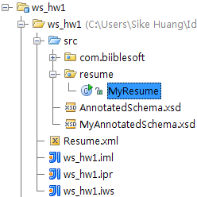

## Printout of your generated Resume.xml file

<?xml version="1.0" encoding="UTF-8" standalone="yes"?>

<Resume xmlns="http://www.biiblesoft.com">

<ContactInfo>

<PersonName>

<GivenName>Sike</GivenName>

<FamilyName>Huang</FamilyName>

</PersonName>

<ContactMethod>

<Phone type="Mobile">

<AreaCityCode>0046</AreaCityCode>

<SubscriberNumber>0762320173</SubscriberNumber>

</Phone>

<InternetEmailAddress>sikeh@kth.se</InternetEmailAddress>

<Postal>

<PostalAddress>Kista Allevag 8B:5</PostalAddress>

<PostalCode>16455</PostalCode>

</Postal>

</ContactMethod>

</ContactInfo>

<EducationHistory>

<Education>

<SchoolName>Vaasa Polytechnic</SchoolName>

<Degree>

<DegreeName>Bachelor</DegreeName>

<DegreeDate>

<Year>2007</Year>

</DegreeDate>

</Degree>

<Major>Software Engineering</Major>

<DissertationName>SINODINE, THE E-RESTAURANT BY FLASH AND JAVA</DissertationName>

<QualificationReference>

<AwardRef>Nokia Award 2005</AwardRef>

</QualificationReference>

</Education>

</EducationHistory>

<Languages>

<Language>

<LanguageName>Chinese</LanguageName>

<Level>Outstanding</Level>

</Language>

<Language>

<LanguageName>English</LanguageName>

<Level>AboveAverage</Level>

</Language>

</Languages>

<SkillSet>

<Skill>

<TechnicalSkill>

<SkillName>Java</SkillName>

<SkillLevel>Outstanding</SkillLevel>

</TechnicalSkill>

<NonTechnicalSkill>

<SkillName>Photography</SkillName>

<SkillLevel>AboveAverage</SkillLevel>

</NonTechnicalSkill>

</Skill>

</SkillSet>

<Hobbies>

<HobbyName>Karaoke</HobbyName>

</Hobbies>

<Experience>

<Employment>

<EmployerInfo>

<EmployerOrgName>Wapice Oy</EmployerOrgName>

<OrgLocationCity>Vaasa, Finland</OrgLocationCity>

<WebSite>http://www.wapice.com/</WebSite>

</EmployerInfo>

<Position>

<Title>Soft Programmer</Title>

<Duration>

<StartDate>

<YearMonth>2007-05</YearMonth>

</StartDate>

</Duration>

</Position>

<ReferencePerson>

<PersonName>

<GivenName>Tuominen</GivenName>

<FamilyName>Pasi</FamilyName>

</PersonName>

<ContactMethod>

<Phone type="Mobile">

<AreaCityCode>00358</AreaCityCode>

<SubscriberNumber>0405793932</SubscriberNumber>

</Phone>

<InternetEmailAddress>pt@wapice.com</InternetEmailAddress>

</ContactMethod>

</ReferencePerson>

<ReasonToLeave>Start Master Studies in Sweden</ReasonToLeave>

</Employment>

</Experience>

</Resume>